INTRODUCING POP ARTIST
IFE ALABA

CLICK HERE TO LISTEN

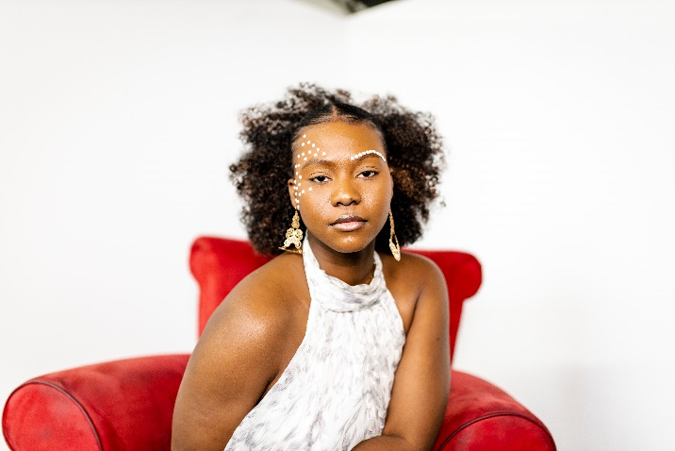
Ife Alaba (Born Ifeoluwa Alaba on June 10, 1999) is a Nigerian singer and songwriter. She grew up in South Africa with a strong musical background spanning from being in choirs, and orchestras, undergoing opera training, and undertaking the trombone. Ife began her music career after moving to Canada, as a performer at the Memorial University of Newfoundland in 2017. She later released her debut single “All By Myself” in January 2020 to much local acclaim due to its numbing ear runs and bleeding emotion. Since then, she has released other singles and featured in other songs. Each song showcases her unique vocal abilities and uses life experiences as a muse for her heart-wrenching hooks. Ife Alaba uses creative but subtle melodies while keeping her music relatable and catchy. She is a powerful vocalist whose music style has been influenced by a mixture of pop, afro, and classical music. She has named other artists such as Laura Mvula, Tiwa Savage, Adele, Beyoncé, Nneka, and Andrea Bocelli as artists who have influenced her. Ife has performed on several stages such as the Black Lives Matter NL protest in 2020, Lawnya Vawnya Festival 2021 and Music NL showcase 2021, ECMA Breakout stage showcase 2022, Iceberg Alley Opening Night, opening for Tim Baker and City in Colour. In addition to her growing musical career, Ife Alaba is also a TV personality, hosting and producing shows such as Stuffed and Being Black in NL on CBC.

Contact Information
Email: ifealaba2@gmail.com
Website: ifealaba.com
Phone: +1(709) 764 2001

Social Media
Instagram: @ife_alaba
Twitter: @ifealaba
Facebook: @ivoalaba

